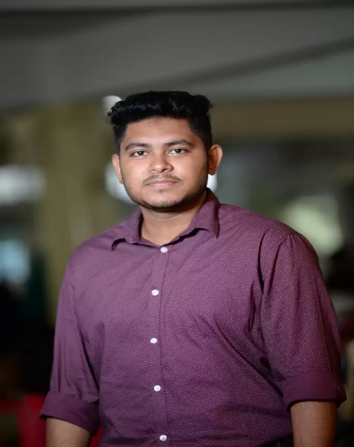

Sayed Islam Safin

I am web developer with a vast array of knowledge in many different front end and back end language,responsive frameworks, database and best code practice. My objective is simply to be the best web developer that I can be and to contribute to the technology industry all that I know and can do. I am dedicated to perfecting my craft by learning from more resources, remaining humble and continuously making strides to learn all that I can about development. My understanding of problem-solving and Research of Computer Vision and Artificial Intelligence are also skills that have and will continue to contribute to my overall success as a developer.

# Address

Kuril, Member Bari ,Dil Foroz Villa   
Dhaka,1229,Bangladesh.

# Education

## American International University Bangladesh

### Computer Science & Engineering

04/2017 – present

* CGPA : **3.71**/4.00
* Clubs :
* AIUB Computer Club(ACC)
* AIUB Competitive Programming Community (ACPC)

# Projects

## Agro Farm Management (Laravel)

* It is a responsive **E-commerce** website for Agro Farm management
* It has three types of user. (Farm owner, Manager, Local User)
* It also has a user **login,registration, CRUD operation, Cart, Transaction calculation, Transaction history visualization in Chart** and maximum feature uses in Ecommerce website

**Javascript,HTML,CSS,Bootstrap** inside **Laravel** framework.

* It is written in **PHP,**
* **MySQL** is used to manage the database.
* Link to GitHub Repository: [**https://github.com/safin777/Agro-farm-laravel**](https://github.com/safin777/Agro-farm-laravel)

## Agro Farm Management(Node Js)

* It is a responsive **E-commerce** website for Agro Farm management
* It has three types of user. (Farm owner, Manager, Local User)
* It also has a user **login,registration, CRUD operation, Cart, Transaction calculation, Transaction history visualization in Chart** and maximum feature uses in Ecommerce website
* It is written in **JavaScript. HTML,CSS,Bootstrap**.
* **MySQL** is used to manage the database.
* Link to GitHub Repository:

<https://github.com/safin777/Agro-farm-Node-> JS

## Agro Farm Application (C#)

* It is a **desktop application** for Agro farm management.
* This project uses **C#** language with **MVC** pattern.
* For managing Agro Farm there are three kinds of users.
* The database is managed by **Microsoft SQL server management studio**.
* Basic **CRUD operation, login, SignUp** and **Mathematical operation**.
* Link to GitHub Repository: **https://github.com/safin777/Agriculture-Farm-Management-System-.Net-Project-/tree/master**

## AIUB Blog (Laravel)

* It is designed with basic **HTML** and **CSS** skills
* It has two types of user.(Admin, Administrative)
* It has a maximum functionality of a blog website.
* **MYSQL** is used for Database management.
* **PHP,Javascript,HTML,CSS,Bootstrap** is used inside Laravel framework.
* Link to Git Repository:**https://github.com/safin777/Individual-assignment**

### Bank Management System. (Node.Js)

* Responsive website using **HTML,CSS,Bootstrap**.
* **Javascript, Node js (ES6)** uses in backend development.
* **MYSQL uses** for Database management.
* Admin, Employee and client three kinds of user can operate the software.
* All **CRUD** and maximum banking functionality and calculation are in this project.
* Git link: **https://github.com/safin777/Bank-**

# Skills

## Programming Languages

PHP ■■■■□

JavaScript ■■■■□

HTML, CSS,JQuery ■■■■□

Bootstrap 4 ■■■■□

React js ■■■□□

MYSQL ■■■■□

C# ■■■■□

Python ■■■□□

Java ■■■□□

## Other Skills

Git version control ■■■■□

JIRA / Meistertask ■■■□□

Wordpress Theme Customization ■■■■□

## Languages

English Professional

Hindi Limited

Bangla Full

## Additional Skill

Python(Tensorflow) ■■■□□

Cpanel ■■■□□

Data Mining ■■■□□

# Experience

## InfoLink Limited

(Web developer Intern)

(20-2-2021 --- in-progress)

## American International University Bangladesh

### AIUB GAMING FEST(2019)

(Event Organiser Volunteer)

# Social Media Link

  [Safin777](https://github.com/safin777)

 [Sayed Islam Safin](http://www.linkedin.com/in/sayed-islam-safin-902a16172)

 [Sayed Islam Safin](https://www.facebook.com/profile.php?id=100009026113118)

 [Sayed Islam Safin](mailto:sayedislamsafin7770555@gmail.com)

# Contact

Phone: 01856777055 / 01625726842

Email: Sayedislamsafin7770555@gmail.com